TASK 1:

PROMPT: generate a Python function that converts an amount from one currency to another using exchange rates stored in a dictionary and ask the user for input values and display it. Example1:100 usd converts to eur output:92.00eur

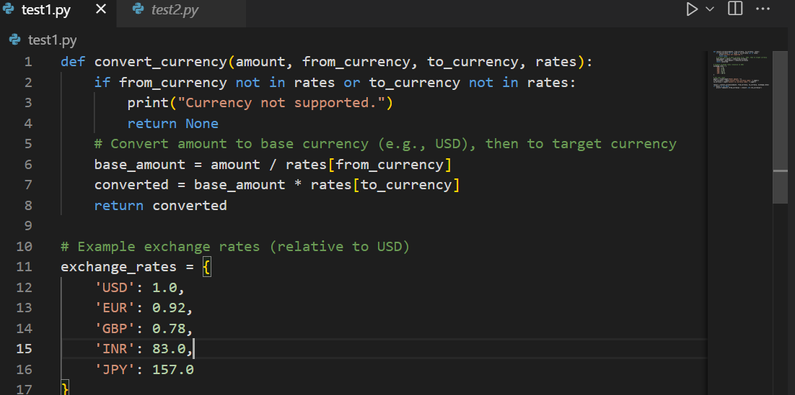

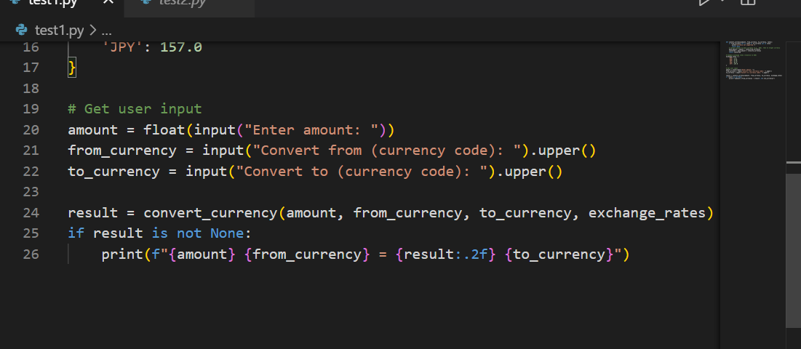

Output:

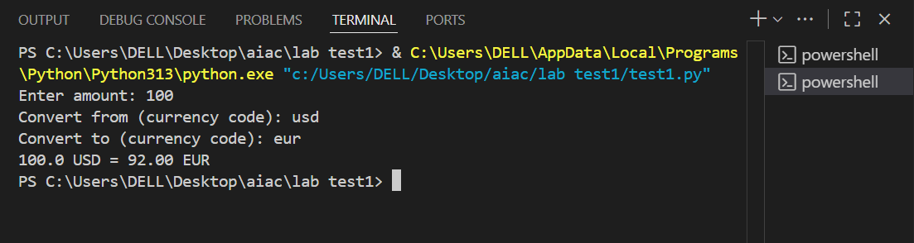

TASK 2:

PROMPT: generate a Python program to extract all email addresses from a block of text using regular  
expressions

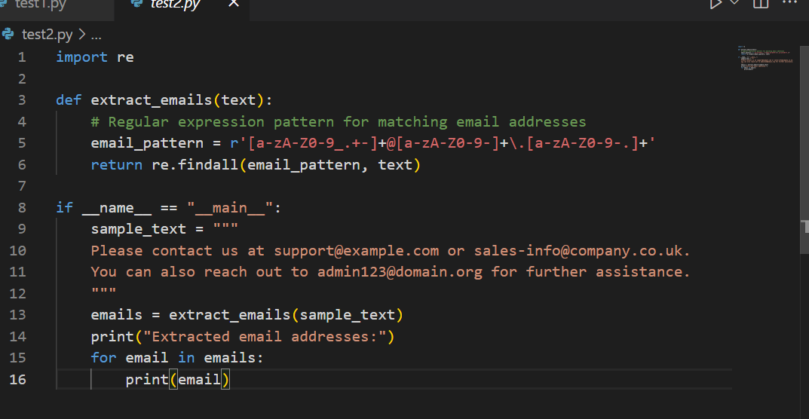

OUTPUT:

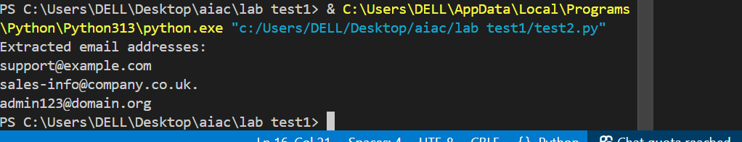

TASK 3:

PROMPT: generate a Python function that recommends movies based on a user’s preferred genreand and Given a list of movies with their genres and ask the input from the consol.Example1: Recommended movies in the genre”action” output: The Dark Knight 2. Recommended movies in the genre”drama” output: Forrest Gump

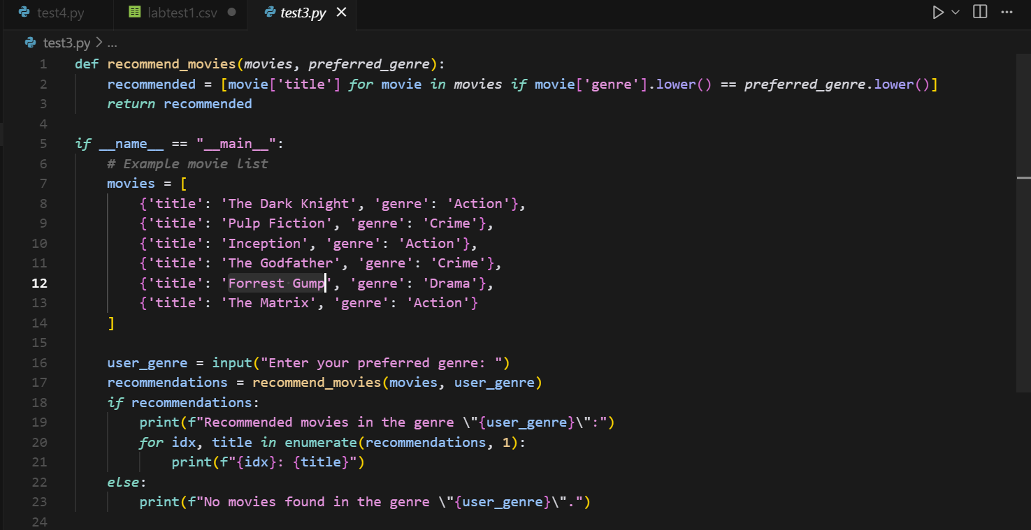

Output:

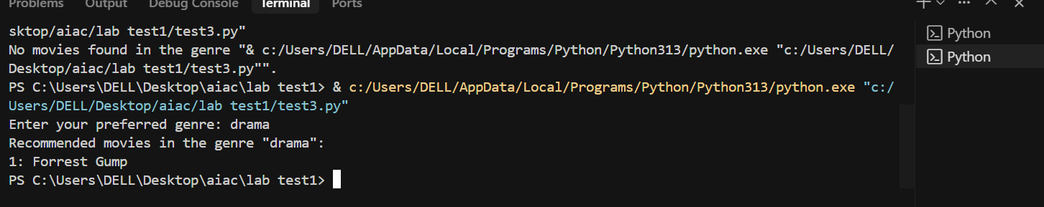

TASK 4:

PROMPT: Write Python code that reads a CSV file containing student names and marks in 3 subjects.Calculate the total and average marks for each student

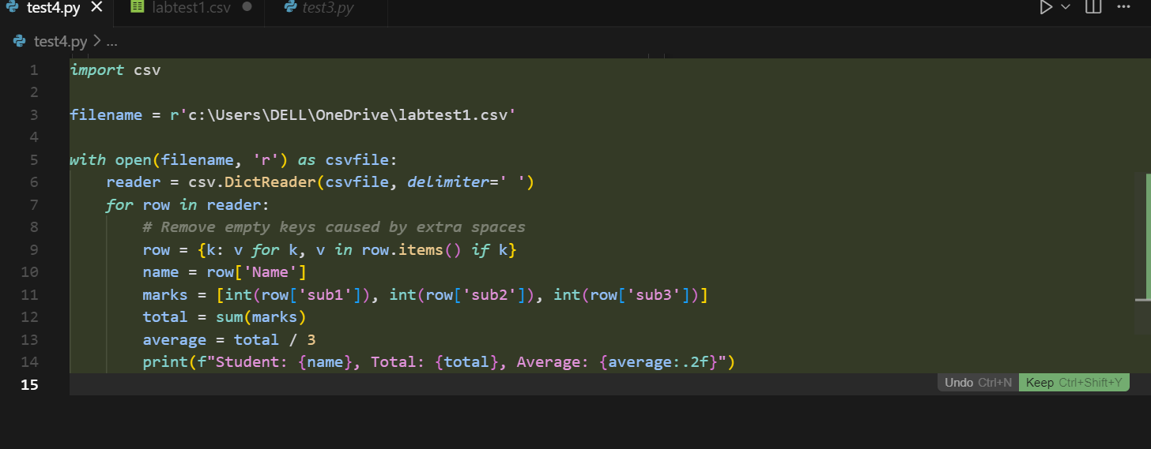

OUTPUT:

